Full stack Web Development

Assignment-1

**Subject: JavaScript**

**Student Name: Mohammed Fazeen Shahfan**

**Student ID: 70141328**

**Submitted to: Engr. Abdul Malik**

Department of Computer Engineering,

The University of Lahore.

Task 1: Build a function-based console log message generator

In this exercise, your task is to code a function named `consoleStyler`, which accepts four parameters:

- `color`

- `background`

- `fontSize`

- `txt`

Inside the body of the consoleStyler() function declaration, you need to do the following:

1. Create a new variable named message, and assign the following to it on the very first line inside the consoleStyler() function body.:

```

"%c" + txt;

```

2. Create a style variable and assign the following to it on the next line:

```

`color: ${color};`

```

3. Next, update the style variable (using the += operator) with the following code:

```

`background: ${background};`

```

4. Then, update the style variable (again, using the += operator) with the following code:

```

`font-size: ${fontSize};`

```

5. Finally, console log the message and style variables inside the `consoleStyler` function declaration.

Hint: Be sure to use backticks (``) when updating your variable styles and not single ('') or double ("") quotes.

<br>

## Task 2: Build another console log message generator.

Your task is to code another function, and name it `celebrateStyler()`. The function accepts a single parameter, reason, which should be of string data type.

Inside the function declaration's body, code the following:

1. A new variable, named fontStyle, assigning it this code:

```

"color: tomato; font-size: 50px";

```

2. On the next line, an if statement, verifying that `reason == "birthday"`.

3. Inside the body of the if block, code the following:

```

console.log(`%cHappy birthday`, fontStyle);

```

4. On the next line, add an else if, and inside the parentheses, check that

```

reason == "champions"

```

5. Inside the else if block, add this code:

```

console.log(`%cCongrats on the title!`, fontStyle);

```

6. Add an else block, with the following code inside of it:

```

console.log(message, style);

```

<br>

## Task 3: Run both the consoleStyler and the celebrateStyler functions

1. Invoke the consoleStyler() function, with the following arguments:

- `'#1d5c63'`

- `'#ede6db'`

- `'40px'`

- `'Congrats!'`

2. Next, invoke the celebrateStyler() function, with the following argument:

- `'birthday'`

## Task 4: Insert a congratulatory and custom message

1. Code another function, named `styleAndCelebrate()`.

The function declaration's body should consist of two function invocations:

```

consoleStyler(color, background, fontSize, txt);

celebrateStyler(reason);

```

2. Next, invoke the new function, using the following arguments:

- `'ef7c8e'`

- `'fae8e0'`

- `'30px'`

- `'You made it!'`

- `'champions'`

<br>

## Final Step: Let's submit your code!

Nice work! To complete this assessment:

1. Save your file through File -> Save

2. Select "Submit Assignment" in your Lab toolbar.

Your code will be autograded and return feedback shortly on the "Grades" tab.

You can also see your score in your Programming Assignment "My Submission" tab.

<br> <br>

### Great job! Please continue to the next lesson.

**Answer:**

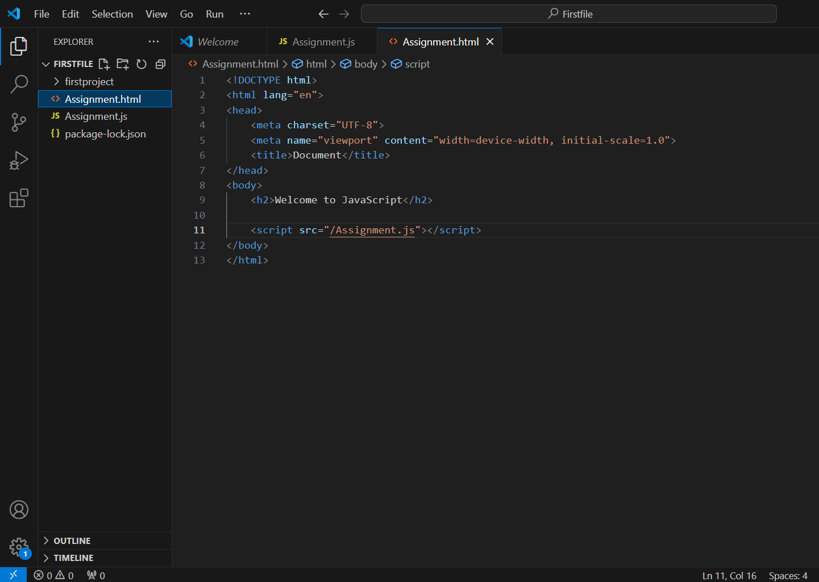

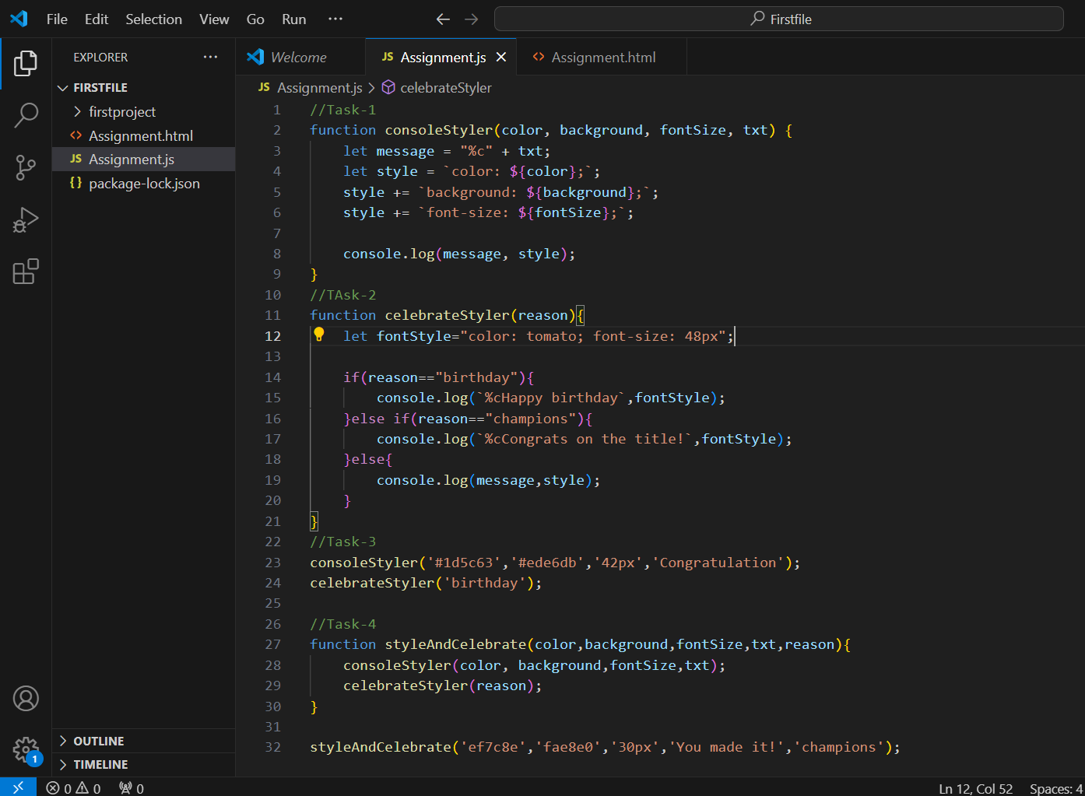

**Link for GitHub**

For more developed and styled Websites Html, CSS and other files : <https://github.com/Fazeen123/Juice-Bar-Project.git>